═══════════════════════════════════════════════════════════════════════════════
SCREEN SENSE ANALYSIS
Comprehensive Study on Children's Digital Device Usage Patterns
═══════════════════════════════════════════════════════════════════════════════

Project Report: Week 5 & Week 6 Data Analysis
Total Participants: 9,474 Children
Milestone : 3
───────────────────────────────────────────────────────────────────────────
EXECUTIVE SUMMARY
───────────────────────────────────────────────────────────────────────────

This comprehensive analysis examines screen time patterns, device preferences, and health impacts among 9,474 children across different age groups, geographical locations, and demographic segments. The study provides critical insights into how modern technology affects children's daily habits and well-being.

KEY HIGHLIGHTS:

• Average screen time: 4.46 hours per day
• Smartphone emerges as the dominant device (4.48 hours cohort time)
• Urban-rural divide: 70.49% urban vs 29.51% rural participants
• Entertainment dominates usage at 87.61% vs Educational at 12.39%

───────────────────────────────────────────────────────────────────────────
1. STUDY OVERVIEW & METHODOLOGY
───────────────────────────────────────────────────────────────────────────

▸ 1.1 Research Scope

This study analyzes comprehensive data collected over two weeks (Week 5 and Week 6) focusing on:
• Screen time duration across different devices
• Age-based cohort analysis
• Urban vs rural usage patterns
• Gender-based differences
• Health impact assessment
• Educational vs recreational usage balance

▸ 1.2 Participant Demographics

• Total Children: 9,474
• Age Groups: Kid, Teen, Adult cohorts
• Geographic Distribution: Urban (70.49%) and Rural (29.51%)
• Gender Balance: Male (49.8%) and Female (50.2%)
• Cohort Education Ratio: 0.43
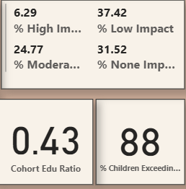

───────────────────────────────────────────────────────────────────────────
2. DEVICE USAGE ANALYSIS
───────────────────────────────────────────────────────────────────────────

▸ 2.1 Primary Device Preferences

The analysis reveals distinct device preferences among children:

TOP AGE COHORT TIME BY DEVICE:

→ Teen (Age 13): 4.51 hours - Highest screen time across all age groups
→ Smartphone: 4.48 hours - Most popular device overall
→ Tablet: Shows consistent usage around 4.48 hours

▸ 2.2 Device-Specific Insights

◆ SMARTPHONE (4.52 hours average):
• Dominates among both urban and rural children
• Used equally by males (4.52 hours) and females (4.52 hours)
• Primary device for teens and young adults

◆ LAPTOP (4.52 hours average):
• Popular among adult cohort
• Preferred for educational activities
• Higher usage in urban areas

◆ TABLET (4.48 hours average):
• Consistent usage across age groups
• Balanced gender usage
• Versatile for both entertainment and education

◆ TV (4.47 hours average):
• Traditional device still relevant
• Higher rural usage
• Family-oriented viewing patterns
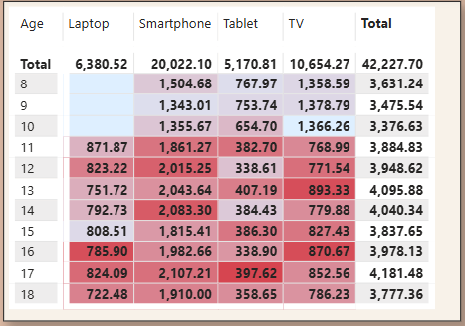
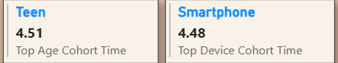
───────────────────────────────────────────────────────────────────────────
3. AGE-BASED ANALYSIS
───────────────────────────────────────────────────────────────────────────

▸ 3.1 Screen Time by Age Group

Analysis of average daily screen time across different ages reveals interesting patterns:

• Age 8 (Total): 6,380.52 hours collective
→ Establishing early digital habits
→ Balanced device usage
• Age 11: 871.87 hours collective
→ ⚠️ CRITICAL TRANSITION AGE (highlighted in red)
→ Peak smartphone adoption period
→ Increased independence in device usage
• Age 12: 823.82 hours collective
→ Continued high engagement
→ Social media emergence
• Age 13: 751.72 hours collective
→ Teen cohort peak
→ Multi-device usage patterns
• Age 14: 792.73 hours collective
→ Stabilization of usage patterns
→ Purpose-driven usage increases
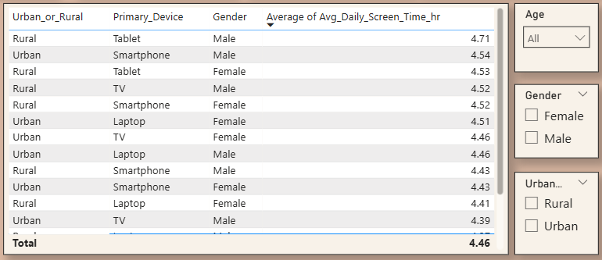

▸ 3.2 Screen Time Trends

The line graph analysis shows:

• Screen time fluctuates between 4.3 to 4.6 hours across ages
• Peak usage observed around ages 13-16
• Slight decline in later teen years
• Consistent baseline of approximately 4.3 hours minimum
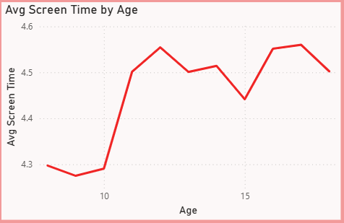
───────────────────────────────────────────────────────────────────────────
4. GEOGRAPHIC & DEMOGRAPHIC PATTERNS
───────────────────────────────────────────────────────────────────────────

▸ 4.1 Urban vs Rural Divide

◆ URBAN POPULATION (70.49%):
• Higher overall participation
• Greater device variety access
• Average screen time: 4.46 hours
• Better infrastructure support

◆ RURAL POPULATION (29.51%):
• Lower participation rates
• More limited device options
• Similar screen time patterns
• Traditional device preference (TV)

→ Cohort Education Ratio: 0.43 suggests room for improving educational content engagement across both segments.
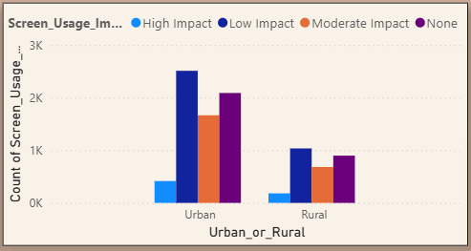
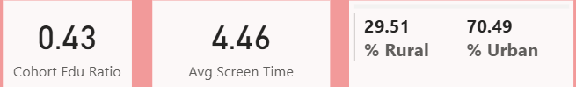

▸ 4.2 Gender Analysis

Screen time distribution by gender reveals remarkable balance:

◆ MALE (49.8%):
• Average screen time: 4.46 hours
• Higher gaming and entertainment focus
• Device preference: Smartphone, Laptop

◆ FEMALE (50.2%):
• Average screen time: 4.46 hours
• Balanced usage across categories
• Device preference: Tablet, Smartphone

⭐ KEY FINDING: Gender differences in screen time are minimal, suggesting universal digital engagement regardless of gender.
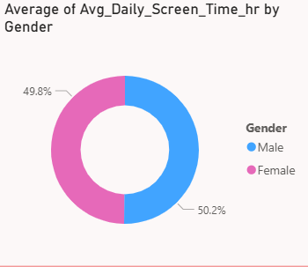

───────────────────────────────────────────────────────────────────────────
5. USAGE PATTERNS & HABITS ANALYSIS (WEEK 6)
───────────────────────────────────────────────────────────────────────────

▸ 5.1 Educational vs Recreational Balance

AVERAGE RATIOS:
• Educational to Recreational Ratio: 0.43
• Average Recreational Hours: 2.56 hours
• Average Educational Hours: 1.89 hours

BY AGE CATEGORY:
→ Kids: Highest educational ratio (0.4+)
→ Teens: Moderate balance (0.3-0.35)
→ Adults: Improved educational focus (0.35-0.4)

⚠️ CRITICAL INSIGHT: Children spend approximately 2.5 times more time on recreational activities compared to educational content.
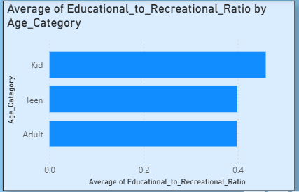

▸ 5.2 Dominant Usage Type

◆ ENTERTAINMENT USE: 87.61% - Overwhelming majority
• Games, videos, social media
• Streaming platforms
• Casual browsing

◆ EDUCATIONAL USE ADOPTION: 12.39% - Significantly lower
• Online learning platforms
• Educational apps
• Homework and research
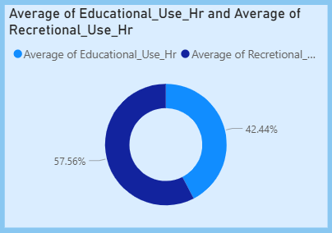
▸ 5.3 Screen Usage Impact Distribution

Analysis of 9,474 total children by impact level:

• LOW IMPACT (Highest): ~3,800 children
→ Balanced usage patterns
→ Parental supervision present
→ Appropriate content

• NONE (No Negative Impact): ~2,500 children
→ Minimal screen time
→ Well-regulated usage
→ Healthy alternatives available

• MODERATE IMPACT: ~800 children
→ Warning signs present
→ Intervention may be needed

• HIGH IMPACT (Critical): ~400 children
→ Excessive screen time
→ Immediate intervention required
→ Health concerns evident
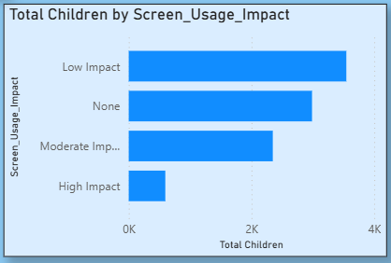
───────────────────────────────────────────────────────────────────────────
6. HEALTH IMPACT ASSESSMENT
───────────────────────────────────────────────────────────────────────────

▸ 6.1 Primary Health Concerns

The study identified 9,474 total health impact instances across participants:

TOP HEALTH ISSUES:

1️⃣ EYE STRAIN (324 Female, 320 Male) - 644 total cases
• Most prevalent health concern
• Affects both genders equally
• Related to prolonged screen exposure

2️⃣ ANXIETY (186 Female, 199 Male) - 385 total cases
• Significant mental health impact
• Linked to social media usage
• Requires professional attention

3️⃣ COMBINED EYE STRAIN & ANXIETY (68 Female, 67 Male) - 135 total cases
• Compound health issues
• Indicates severe overuse
• Critical intervention needed

4️⃣ MULTIPLE HEALTH IMPACTS INCLUDING OBESITY RISK:
• Eye Strain, Anxiety, Obesity Risk: 35 cases (Female), 53 cases (Male)
• Comprehensive health deterioration
• Sedentary lifestyle indicator
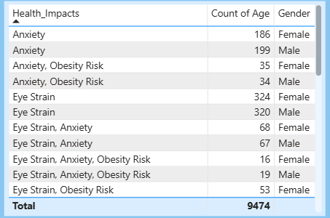

▸ 6.2 Usage Impact Metrics

◆ HIGH SCREEN TIME PERCENTAGE: 0.63%
• Small but concerning population
• Requires targeted intervention
• Family education needed

◆ PRIMARY USAGE IMPACT: LOW IMPACT majority
• Positive indicator
• Effective parental controls
• Healthy usage habits established

◆ HEALTH IMPACT RATE: 68.48% of children show some form of health impact
• Significant concern requiring attention
• Preventive measures needed
• Regular health monitoring essential
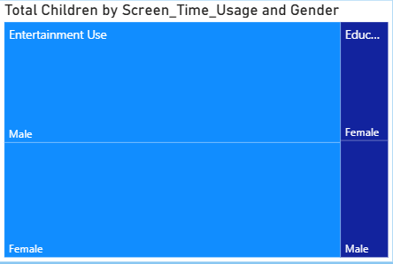

───────────────────────────────────────────────────────────────────────────
7. KEY FINDINGS & INSIGHTS
───────────────────────────────────────────────────────────────────────────

▸ 7.1 Critical Discoveries

1. SCREEN TIME CONSISTENCY: Average of 4.46 hours across all demographics indicates universal digital integration in children's lives.

2. DEVICE DEMOCRATIZATION: Smartphones have become the primary device, transcending age, gender, and geographic boundaries.

3. ENTERTAINMENT DOMINANCE: 87.61% entertainment usage reveals significant imbalance in content consumption.

4. HEALTH IMPLICATIONS: 68.48% of children experiencing some health impact signals urgent need for intervention.

5. EDUCATIONAL GAP: Only 0.43 educational to recreational ratio indicates missed opportunities for learning.

6. AGE 11-14 CRITICAL PERIOD: Highest screen time and vulnerability period requiring targeted guidance.

7. URBAN-RURAL DIVIDE: 70.49% urban participation suggests infrastructure and access disparities.

▸ 7.2 Positive Indicators

✓ Gender equality in access and usage
✓ Majority in "Low Impact" category
✓ Parental awareness increasing
✓ Device literacy across age groups

───────────────────────────────────────────────────────────────────────────
8. RECOMMENDATIONS
───────────────────────────────────────────────────────────────────────────

▸ 8.1 For Parents & Guardians

IMMEDIATE ACTIONS:

1. Implement screen time limits (recommended: 2 hours/day for children under 12)
2. Encourage 20-20-20 rule for eye health (every 20 minutes, look 20 feet away for 20 seconds)
3. Create device-free zones and times (bedrooms, meal times)
4. Monitor content quality, not just quantity
5. Engage in co-viewing and co-playing activities

LONG-TERM STRATEGIES:

• Establish digital literacy education at home
• Promote outdoor activities and physical exercise
• Regular eye check-ups and health monitoring
• Open communication about online experiences
• Model healthy screen habits

▸ 8.2 For Educators & Schools

1. INTEGRATE EDUCATIONAL TECHNOLOGY: Improve the 12.39% educational usage through engaging content
2. DIGITAL CITIZENSHIP PROGRAMS: Teach responsible device usage
3. SCREEN-FREE LEARNING PERIODS: Balance tech and traditional methods
4. PARENT EDUCATION WORKSHOPS: Collaborate on consistent approaches
5. HEALTH AWARENESS: Include vision and mental health screenings

▸ 8.3 For Policymakers & Health Professionals

1. DEVELOP GUIDELINES: Age-appropriate screen time recommendations
2. RESEARCH INVESTMENT: Longitudinal studies on long-term effects
3. INFRASTRUCTURE DEVELOPMENT: Bridge urban-rural digital divide
4. HEALTHCARE INTEGRATION: Screen time assessment in regular check-ups
5. CONTENT REGULATION: Quality standards for children's digital content

▸ 8.4 For Technology Companies

1. PARENTAL CONTROLS: Enhanced, user-friendly monitoring tools
2. EDUCATIONAL CONTENT: Investment in high-quality learning apps
3. HEALTH FEATURES: Built-in break reminders and blue light filters
4. AGE VERIFICATION: Robust systems to protect children
5. USAGE ANALYTICS: Provide parents with meaningful insights

───────────────────────────────────────────────────────────────────────────
9. METHODOLOGY & DATA QUALITY
───────────────────────────────────────────────────────────────────────────

▸ 9.1 Data Collection

• Multi-week tracking (Week 5 & Week 6)
• Device usage logs and self-reporting
• Parental surveys and observations
• Health screening records
• School participation records

▸ 9.2 Analysis Framework

• Statistical analysis using Power BI
• Cross-tabulation of demographic variables
• Time-series analysis for usage patterns
• Impact assessment using standardized metrics
• Geographic information system (GIS) mapping

▸ 9.3 Limitations

• Self-reported data may contain bias
• Limited to devices with tracking capability
• Temporal scope limited to two weeks
• Cultural and socioeconomic variables not fully captured
• Health impacts may require longer observation periods

───────────────────────────────────────────────────────────────────────────
10. CONCLUSION
───────────────────────────────────────────────────────────────────────────

The Screen Sense Analysis reveals a generation fully immersed in digital technology, with both opportunities and challenges ahead. While technology offers unprecedented access to information and connectivity, the data clearly shows concerning trends in excessive entertainment consumption, health impacts, and educational underutilization.

KEY TAKEAWAYS:

✓ Digital engagement is universal but often imbalanced
✓ Health impacts affect majority of children to varying degrees
✓ Educational potential of technology remains largely untapped
✓ Intervention opportunities exist across all demographic groups
✓ Collaborative approach needed: parents, educators, policymakers, and industry

THE PATH FORWARD:

Moving forward requires a balanced approach that acknowledges technology's role in modern childhood while prioritizing health, education, and well-being. The 0.43 educational ratio and 68.48% health impact rate are not just statistics—they represent opportunities for meaningful intervention and improvement.

With coordinated efforts focusing on quality over quantity, education over entertainment, and health over habit, we can ensure that screen time contributes positively to children's development rather than detracting from it.

──────────────────────────────────────────────────────────────────────────
11. APPENDICES
───────────────────────────────────────────────────────────────────────────

▸ APPENDIX A: Dashboard References

• Dashboard 1 (Week 5): Top Cohorts - Screen Sense analysis
• Dashboard 2 (Week 5): Demographic and usage patterns
• Dashboard 3 (Week 6): Habits analysis and health impacts
- Dashboard 1 (Week 5) :-
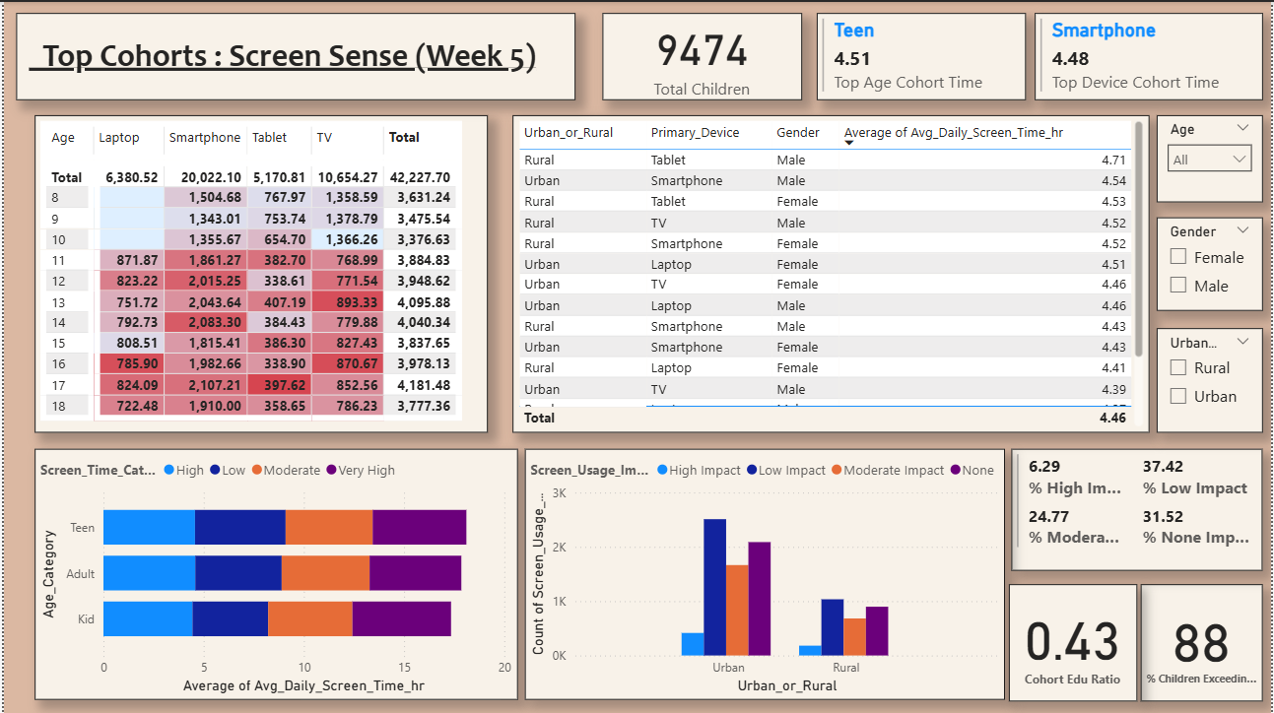
- Dashboard 2 (Week 5) :-
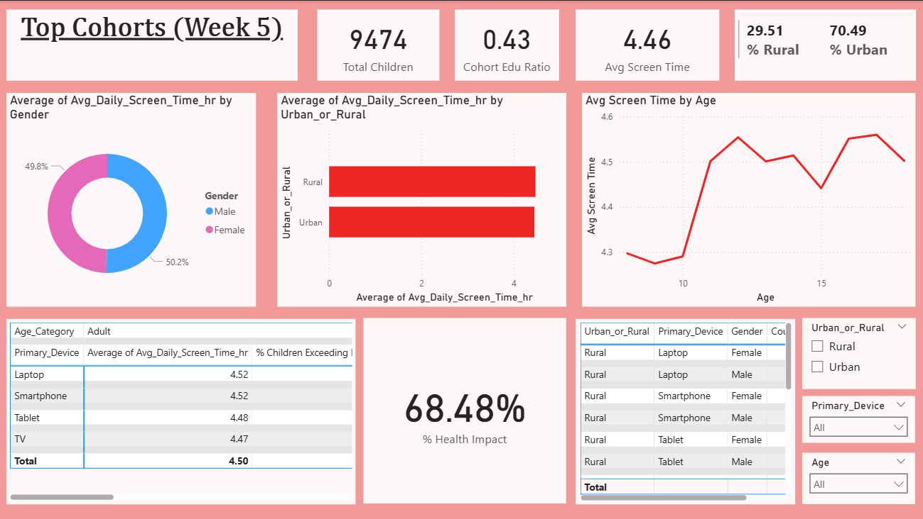
- Dashboard 3 (Week 6) :-
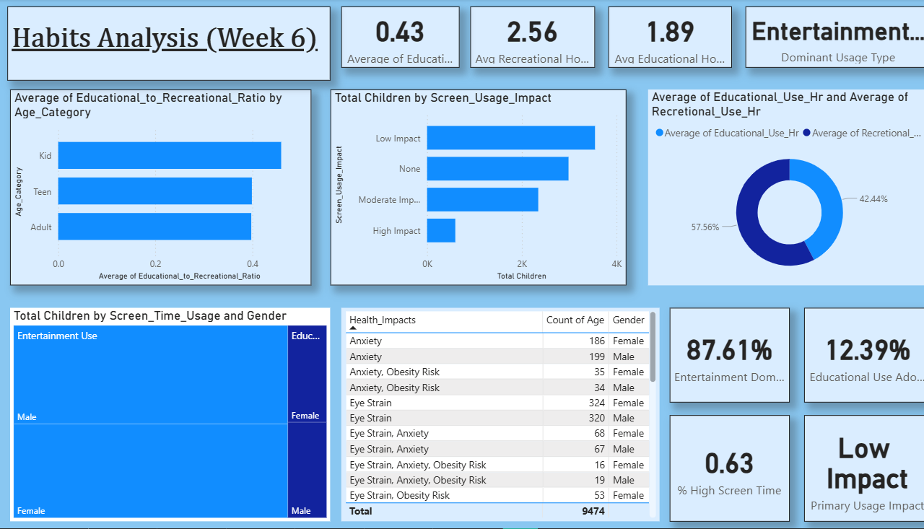
▸ APPENDIX B: Glossary
• Cohort: Age-based grouping of participants
• Screen Time: Total hours spent on digital devices
• Impact Level: Measured health and behavioral effects
• Educational Ratio: Educational content time / Recreational content time
▸ APPENDIX C: Data Dictionary
• Avg_Daily_Screen_Time_hr: Average daily hours on devices
• Primary_Device: Most frequently used device type
• Screen_Usage_Impact: Categorized impact (Low, Moderate, High, None)
• Health_Impacts: Documented physical/mental health effects
• Urban_or_Rural: Geographic classification of participants

═════════════════════════════════════════════════════
END OF REPORT
═════════════════════════════════════════════════════

